GRADE 7 ACCELERATED · UNIT 1 · LESSON 5
Solving Problems with Equations
Worksheet 7A.01.05 ANSWER KEY

For questions 1 and 2, rewrite the expression by applying the distributive property.
1. 6(x + 4)
6x + 24
6 multiplies both terms inside the parentheses.

2. (b − 9)(−4)
−4b + 36
(−4)(b) = −4b and (−4)(−9) = +36. The factor on the right multiplies both terms just the same.
Equations of the form a(b + c) = d can be solved two ways: distribute the a first, or divide both sides by a first.
3. Solve 4(1 − 3x) = 52 using each method.
Method 1  Distribute first | Method 2  Divide both sides first
4 − 12x = 52  −12x = 48  x = −4 | 1 − 3x = 13  −3x = 12  x = −4
Both methods give x = −4. Check: 4(1 − 3(−4)) = 4(1 + 12) = 4(13) = 52.

For questions 4 through 7, solve using your preferred method, then check your solution by substitution.

 | 4. |  | (x + 2) = 12

x + 2 = 12 ÷ (3/10) = 12 × (10/3) = 40
x = 38
Check: (3/10)(38 + 2) = (3/10)(40) = 12 ✓
Dividing first is quicker here. Distributing gives (3/10)x + 3/5 = 12, which works but is messier.
5. 0.2(r − 3) = −10
r − 3 = −10 ÷ 0.2 = −50
r = −47
Check: 0.2(−47 − 3) = 0.2(−50) = −10 ✓
Dividing by 0.2 is the same as multiplying by 5.

 | 6. |  | ( x + | 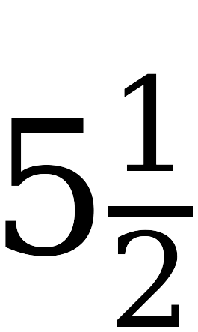 | ) = | 

x + 5½ = (5/8) ÷ (3/4) = (5/8)(4/3) = 5/6
x = 5/6 − 11/2 = 5/6 − 33/6 = −28/6 = −4 2/3
Check: (3/4)(−4 2/3 + 5 1/2) = (3/4)(5/6) = 5/8 ✓
Multiplying by the reciprocal 4/3 is the efficient move. Answer as a mixed number: −4 2/3.
7. 911.32 = 21.74p + 780.88
911.32 − 780.88 = 21.74p
130.44 = 21.74p
p = 6
Check: 21.74(6) + 780.88 = 130.44 + 780.88 = 911.32 ✓
No parentheses here — this one is a plain two-step equation, and the numbers are only large, not hard.

A local plumber charges a $75 fee for a home visit plus $66.24 per hour while working. The total bill was $339.96.
8. Write an equation for this situation. Use h for the number of hours the plumber worked.
75 + 66.24h = 339.96
The $75 is charged once, so it is the constant. The $66.24 depends on h, so it is the coefficient.
9. Solve the equation.
66.24h = 264.96
h = 4
Check: 75 + 66.24(4) = 75 + 264.96 = 339.96 ✓
10. Explain what the solution means in this situation.
The plumber worked for 4 hours.
Watch for students who answer “$264.96.” That is what the hours cost, not the number of hours.

